23 — Навигация в compose от 19.09.26 9ИС-360 Чайкин А.

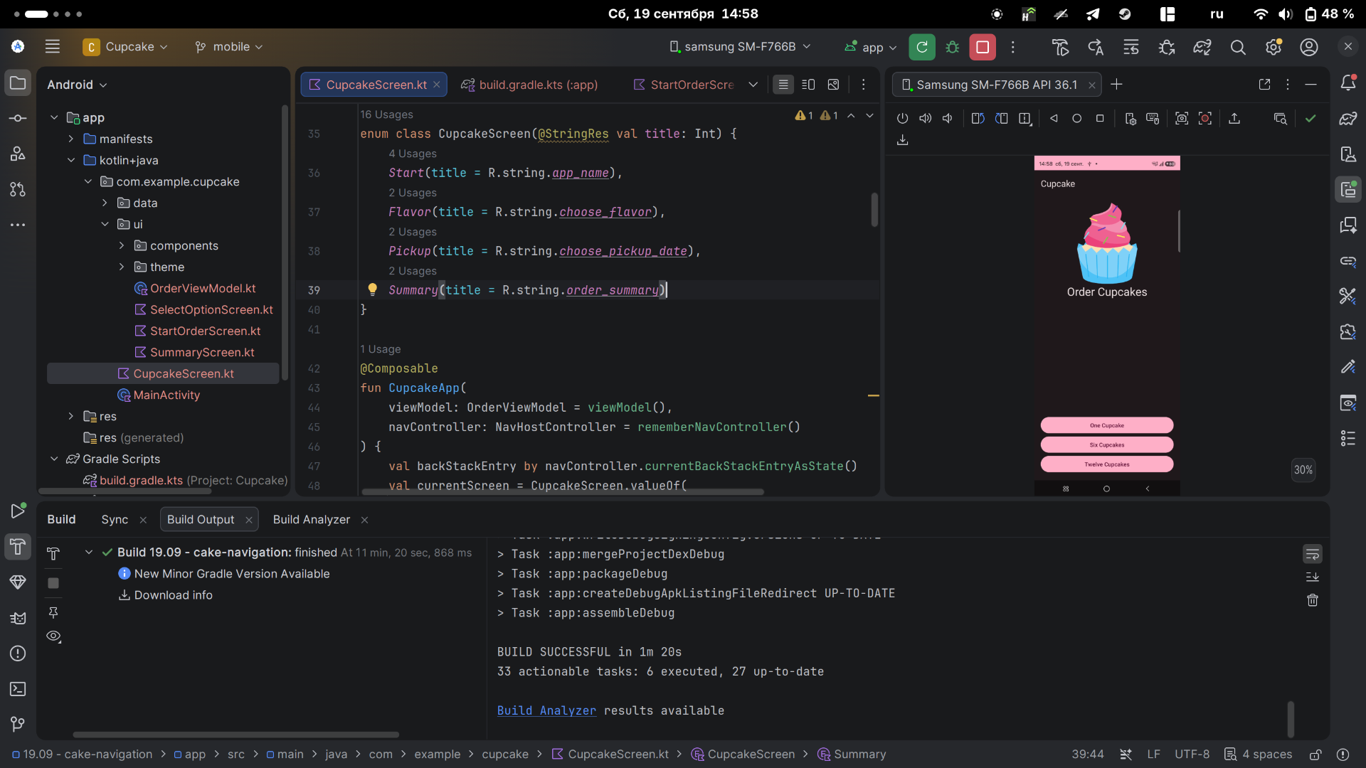
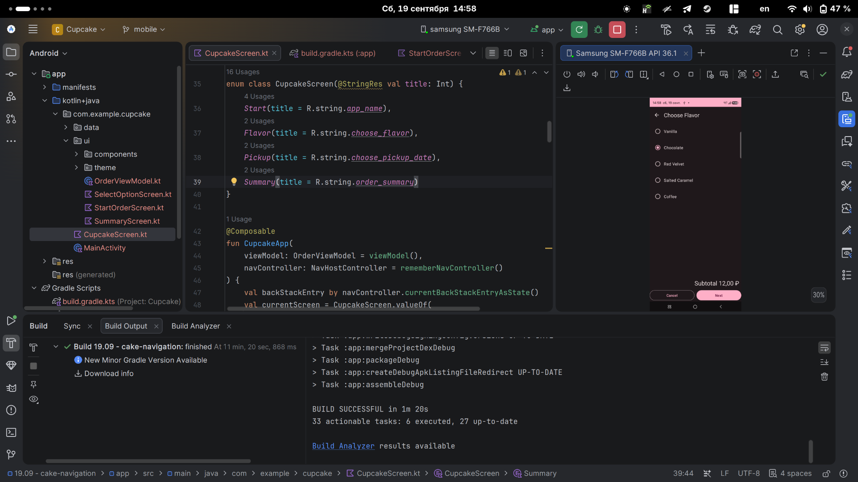
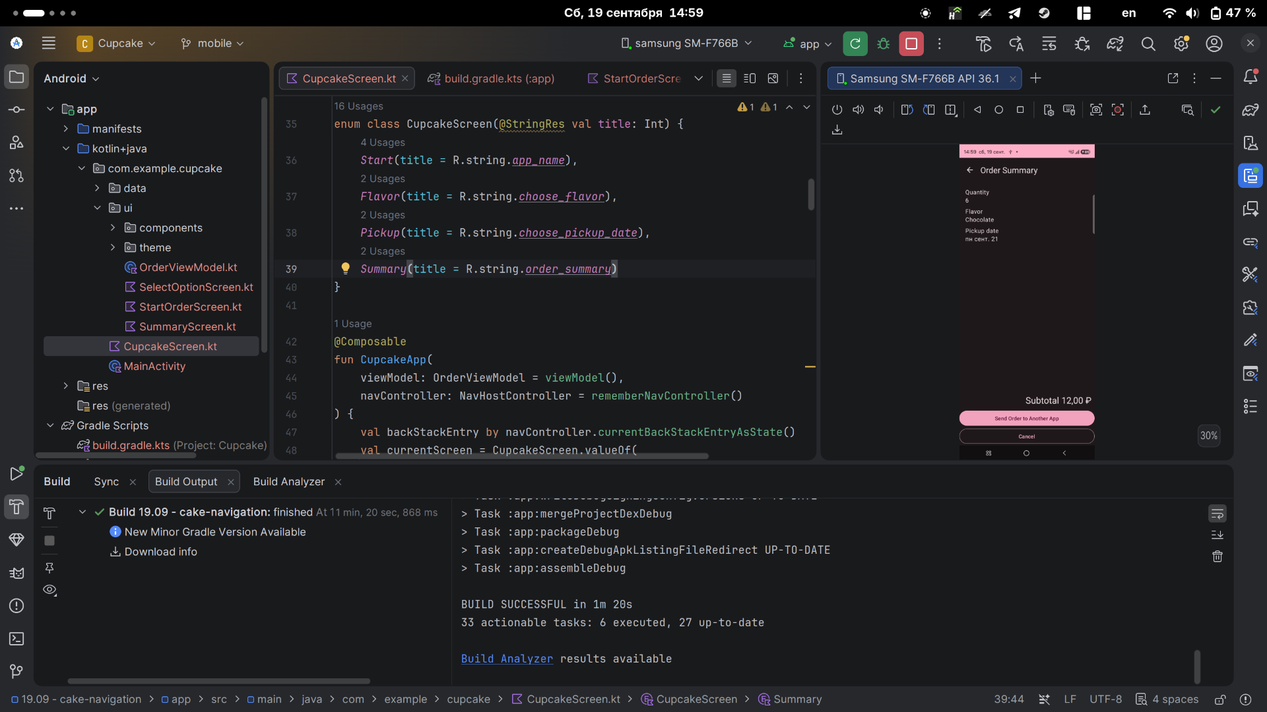
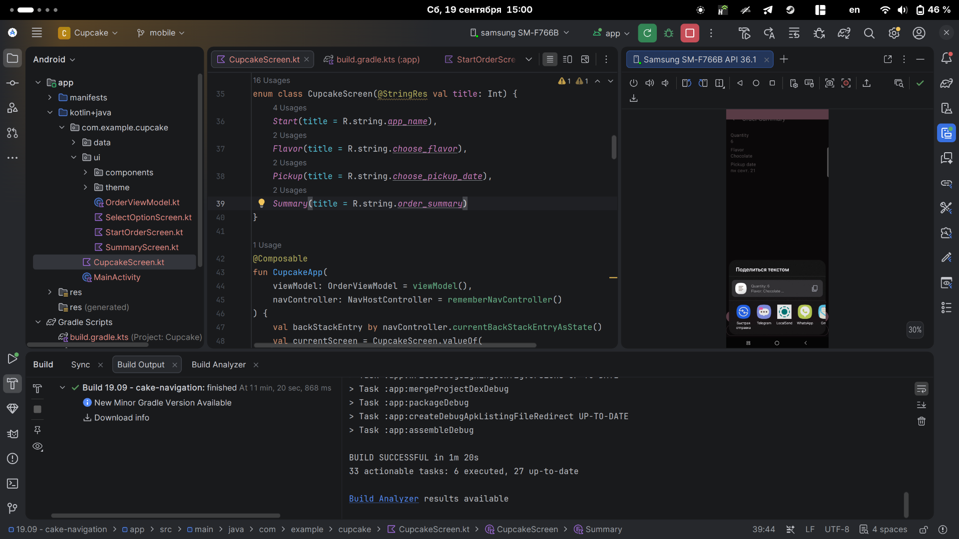
Quantity: 12
Flavor: Salted Caramel
Pickup date: пн сент. 21
Total: 24,00 ₽

Thank you!

CupcakeScreen.kt

package com.example.cupcake
import androidx.annotation.StringRes
import android.content.Context
import android.content.Intent
import androidx.compose.foundation.layout.fillMaxHeight
import androidx.compose.foundation.layout.fillMaxSize
import androidx.compose.foundation.layout.padding
import androidx.compose.material.icons.Icons
import androidx.compose.material.icons.filled.ArrowBack
import androidx.compose.material3.Icon
import androidx.compose.material3.IconButton
import androidx.compose.material3.Scaffold
import androidx.compose.material3.Text
import androidx.compose.material3.TopAppBar
import androidx.compose.runtime.Composable
import androidx.compose.runtime.collectAsState
import androidx.compose.runtime.getValue
import androidx.compose.ui.Modifier
import androidx.compose.ui.platform.LocalContext
import androidx.compose.ui.res.dimensionResource
import androidx.compose.ui.res.stringResource
import androidx.lifecycle.viewmodel.compose.viewModel
import androidx.navigation.NavHostController
import androidx.navigation.compose.NavHost
import androidx.navigation.compose.composable
import androidx.navigation.compose.currentBackStackEntryAsState
import androidx.navigation.compose.rememberNavController
import com.example.cupcake.data.DataSource
import com.example.cupcake.ui.OrderSummaryScreen
import com.example.cupcake.ui.OrderViewModel
import com.example.cupcake.ui.SelectOptionScreen
import com.example.cupcake.ui.StartOrderScreen
enum class CupcakeScreen(@StringRes val title: Int) {
Start(title = R.string.app_name),
Flavor(title = R.string.choose_flavor),
Pickup(title = R.string.choose_pickup_date),
Summary(title = R.string.order_summary)
}
@Composable
fun CupcakeApp(
viewModel: OrderViewModel = viewModel(),
navController: NavHostController = rememberNavController()
) {
val backStackEntry by navController.currentBackStackEntryAsState()
val currentScreen = CupcakeScreen.valueOf(
backStackEntry?.destination?.route ?: CupcakeScreen.Start.name
)
Scaffold(
topBar = {
CupcakeAppBar(
currentScreen = currentScreen,
canNavigateBack = navController.previousBackStackEntry != null,
navigateUp = { navController.navigateUp() }
)
}
) { innerPadding ->
val uiState by viewModel.uiState.collectAsState()
NavHost(
navController = navController,
startDestination = CupcakeScreen.Start.name,
modifier = Modifier.padding(innerPadding)
) {
composable(route = CupcakeScreen.Start.name) {
StartOrderScreen(
quantityOptions = DataSource.quantityOptions,
onNextButtonClicked = {
viewModel.setQuantity(it)
navController.navigate(CupcakeScreen.Flavor.name)
},
modifier = Modifier
.fillMaxSize()
.padding(dimensionResource(R.dimen.padding_medium))
)
}
composable(route = CupcakeScreen.Flavor.name) {
val context = LocalContext.current
SelectOptionScreen(
subtotal = uiState.price,
options = DataSource.flavors.map { id ->
context.resources.getString(id)
},
onSelectionChanged = { viewModel.setFlavor(it) },
onCancelButtonClicked = {
cancelOrderAndNavigateToStart(viewModel, navController)
},
onNextButtonClicked = {
navController.navigate(CupcakeScreen.Pickup.name)
},
modifier = Modifier.fillMaxHeight()
)
}
composable(route = CupcakeScreen.Pickup.name) {
SelectOptionScreen(
subtotal = uiState.price,
options = uiState.pickupOptions,
onSelectionChanged = { viewModel.setDate(it) },
onCancelButtonClicked = {
cancelOrderAndNavigateToStart(viewModel, navController)
},
onNextButtonClicked = {
navController.navigate(CupcakeScreen.Summary.name)
},
modifier = Modifier.fillMaxHeight()
)
}
composable(route = CupcakeScreen.Summary.name) {
val context = LocalContext.current
OrderSummaryScreen(
orderUiState = uiState,
onCancelButtonClicked = {
cancelOrderAndNavigateToStart(viewModel, navController)
},
onSendButtonClicked = { subject: String, summary: String ->
shareOrder(context, subject, summary)
},
modifier = Modifier.fillMaxHeight()
)
}
}
}
}
@Composable
fun CupcakeAppBar(
currentScreen: CupcakeScreen,
canNavigateBack: Boolean,
navigateUp: () -> Unit = {},
modifier: Modifier = Modifier
) {
TopAppBar(
title = { Text(stringResource(currentScreen.title)) },
modifier = modifier,
navigationIcon = {
if (canNavigateBack) {
IconButton(onClick = navigateUp) {
Icon(
imageVector = Icons.Filled.ArrowBack,
contentDescription = stringResource(R.string.back_button)
)
}
}
}
)
}
private fun cancelOrderAndNavigateToStart(
viewModel: OrderViewModel,
navController: NavHostController
) {
viewModel.resetOrder()
navController.popBackStack(
route = CupcakeScreen.Start.name,
inclusive = false
)
}
private fun shareOrder(
context: Context,
subject: String,
summary: String
) {
val intent = Intent(Intent.ACTION_SEND).apply {
type = "text/plain"
putExtra(Intent.EXTRA_SUBJECT, subject)
putExtra(Intent.EXTRA_TEXT, summary)
}
context.startActivity(
Intent.createChooser(
intent,
context.getString(R.string.new_cupcake_order)
)
)
}

StartOrderScreen.kt

package com.example.cupcake.ui
import androidx.compose.foundation.Image
import androidx.compose.foundation.layout.Arrangement
import androidx.compose.foundation.layout.Column
import androidx.compose.foundation.layout.fillMaxSize
import androidx.compose.foundation.layout.fillMaxWidth
import androidx.compose.foundation.layout.padding
import androidx.compose.foundation.layout.size
import androidx.compose.material3.Button
import androidx.compose.material3.ButtonDefaults
import androidx.compose.material3.MaterialTheme
import androidx.compose.material3.Text
import androidx.compose.runtime.Composable
import androidx.compose.ui.Alignment
import androidx.compose.ui.Modifier
import androidx.compose.ui.res.dimensionResource
import androidx.compose.ui.res.painterResource
import androidx.compose.ui.res.stringResource
import androidx.compose.ui.tooling.preview.Preview
import androidx.compose.ui.unit.dp
import com.example.cupcake.R
import com.example.cupcake.data.DataSource
import com.example.cupcake.ui.theme.CupcakeTheme
@Composable
fun StartOrderScreen(
quantityOptions: List<Pair<Int, Int>>,
onNextButtonClicked: (Int) -> Unit,
modifier: Modifier = Modifier
) {
Column(
modifier = modifier,
verticalArrangement = Arrangement.SpaceBetween
) {
Column(
modifier = Modifier.fillMaxWidth(),
horizontalAlignment = Alignment.CenterHorizontally
) {
Image(
painter = painterResource(R.drawable.cupcake),
contentDescription = null,
modifier = Modifier.size(200.dp)
)
Text(
text = stringResource(R.string.order_cupcakes),
style = MaterialTheme.typography.headlineMedium
)
}
Column {
quantityOptions.forEach { item ->
SelectQuantityButton(
labelResourceId = item.first,
onClick = { onNextButtonClicked(item.second) }
)
}
}
}
}
@Composable
fun SelectQuantityButton(
labelResourceId: Int,
onClick: () -> Unit,
modifier: Modifier = Modifier
) {
Button(
onClick = onClick,
modifier = modifier.fillMaxWidth(),
colors = ButtonDefaults.buttonColors(
containerColor = MaterialTheme.colorScheme.primary
)
) {
Text(text = stringResource(labelResourceId))
}
}
@Preview
@Composable
fun StartOrderPreview() {
CupcakeTheme {
StartOrderScreen(
quantityOptions = DataSource.quantityOptions,
onNextButtonClicked = {},
modifier = Modifier
.fillMaxSize()
.padding(dimensionResource(R.dimen.padding_medium))
)
}
}

SelectOptionScreen.kt

package com.example.cupcake.ui
import androidx.compose.foundation.layout.Arrangement
import androidx.compose.foundation.layout.Column
import androidx.compose.foundation.layout.Row
import androidx.compose.foundation.layout.Spacer
import androidx.compose.foundation.layout.fillMaxWidth
import androidx.compose.foundation.layout.padding
import androidx.compose.foundation.layout.width
import androidx.compose.material3.Button
import androidx.compose.material3.OutlinedButton
import androidx.compose.material3.RadioButton
import androidx.compose.material3.Text
import androidx.compose.runtime.Composable
import androidx.compose.runtime.getValue
import androidx.compose.runtime.mutableStateOf
import androidx.compose.runtime.saveable.rememberSaveable
import androidx.compose.runtime.setValue
import androidx.compose.ui.Alignment
import androidx.compose.ui.Modifier
import androidx.compose.ui.res.stringResource
import androidx.compose.ui.unit.dp
import com.example.cupcake.R
import com.example.cupcake.ui.components.FormattedPriceLabel
@Composable
fun SelectOptionScreen(
subtotal: String,
options: List<String>,
onSelectionChanged: (String) -> Unit = {},
onCancelButtonClicked: () -> Unit = {},
onNextButtonClicked: () -> Unit = {},
modifier: Modifier = Modifier
) {
var selectedValue by rememberSaveable { mutableStateOf("") }
Column(
modifier = modifier,
verticalArrangement = Arrangement.SpaceBetween
) {
Column {
options.forEach { option ->
Row(
modifier = Modifier
.fillMaxWidth()
.padding(8.dp),
verticalAlignment = Alignment.CenterVertically
) {
RadioButton(
selected = option == selectedValue,
onClick = {
selectedValue = option
onSelectionChanged(option)
}
)
Text(option)
}
}
}
Column {
FormattedPriceLabel(
subtotal = subtotal,
modifier = Modifier
.align(Alignment.End)
.padding(8.dp)
)
Row(
modifier = Modifier.fillMaxWidth(),
horizontalArrangement = Arrangement.SpaceBetween
) {
OutlinedButton(
modifier = Modifier.weight(1f),
onClick = onCancelButtonClicked
) {
Text(stringResource(R.string.cancel))
}
Spacer(modifier = Modifier.width(8.dp))
Button(
modifier = Modifier.weight(1f),
enabled = selectedValue.isNotEmpty(),
onClick = onNextButtonClicked
) {
Text(stringResource(R.string.next))
}
}
}
}
}

SummaryScreen.kt

package com.example.cupcake.ui
import androidx.compose.foundation.layout.Arrangement
import androidx.compose.foundation.layout.Column
import androidx.compose.foundation.layout.Spacer
import androidx.compose.foundation.layout.fillMaxHeight
import androidx.compose.foundation.layout.fillMaxWidth
import androidx.compose.foundation.layout.height
import androidx.compose.foundation.layout.padding
import androidx.compose.material3.Button
import androidx.compose.material3.OutlinedButton
import androidx.compose.material3.Text
import androidx.compose.runtime.Composable
import androidx.compose.ui.Alignment
import androidx.compose.ui.Modifier
import androidx.compose.ui.res.stringResource
import androidx.compose.ui.tooling.preview.Preview
import androidx.compose.ui.unit.dp
import com.example.cupcake.R
import com.example.cupcake.data.OrderUiState
import com.example.cupcake.ui.components.FormattedPriceLabel
import com.example.cupcake.ui.theme.CupcakeTheme
@Composable
fun OrderSummaryScreen(
orderUiState: OrderUiState,
onCancelButtonClicked: () -> Unit,
onSendButtonClicked: (String, String) -> Unit,
modifier: Modifier = Modifier
) {
val newOrder = stringResource(R.string.new_cupcake_order)
val orderSummary = stringResource(
R.string.order_details,
orderUiState.quantity,
orderUiState.flavor,
orderUiState.date,
orderUiState.price
)
Column(
modifier = modifier,
verticalArrangement = Arrangement.SpaceBetween
) {
Column(
modifier = Modifier
.fillMaxWidth()
.padding(16.dp)
) {
Text(stringResource(R.string.quantity))
Text(orderUiState.quantity.toString())
Spacer(Modifier.height(8.dp))
Text(stringResource(R.string.flavor))
Text(orderUiState.flavor)
Spacer(Modifier.height(8.dp))
Text(stringResource(R.string.pickup_date))
Text(orderUiState.date)
Spacer(Modifier.height(8.dp))
}
Column {
FormattedPriceLabel(
subtotal = orderUiState.price,
modifier = Modifier
.align(Alignment.End)
.padding(8.dp)
)
Button(
modifier = Modifier.fillMaxWidth(),
onClick = { onSendButtonClicked(newOrder, orderSummary) }
) {
Text(stringResource(R.string.send))
}
OutlinedButton(
modifier = Modifier.fillMaxWidth(),
onClick = onCancelButtonClicked
) {
Text(stringResource(R.string.cancel))
}
}
}
}
@Preview
@Composable
fun OrderSummaryPreview() {
CupcakeTheme {
OrderSummaryScreen(
orderUiState = OrderUiState(0, "Test", "Test", "$300.00"),
onSendButtonClicked = { _: String, _: String -> },
onCancelButtonClicked = {},
modifier = Modifier.fillMaxHeight()
)
}
}

